3/15/2023

Paramita

Book Management [Wireframe Doc.]

Project:ineuron[Enterprise Java Batch-2023]

**The Wireframe document presents the web pages in sequence as they are accessed:**

**On Execution of the project the user comes to the landing page[index.jsp]:**

**[built with Carousel controls]**

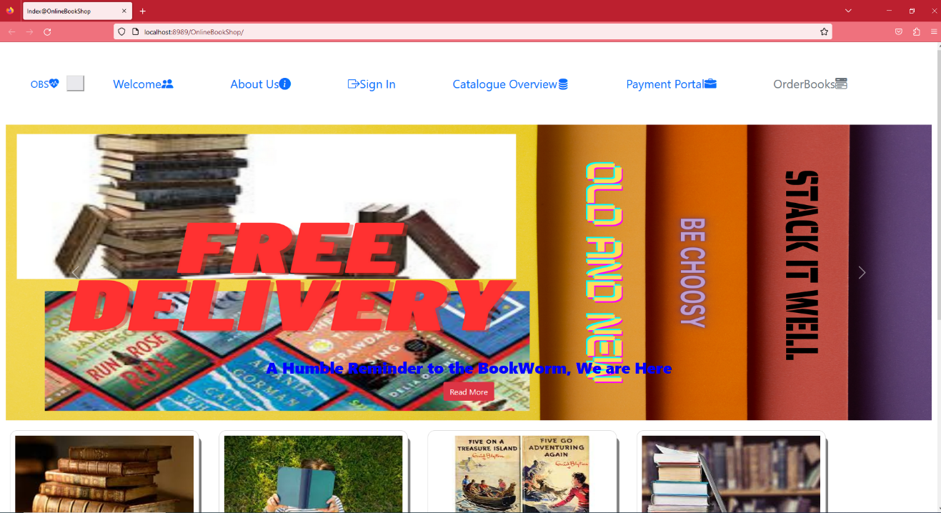

**The page is responsive[with iconbars on the righthand top side]**

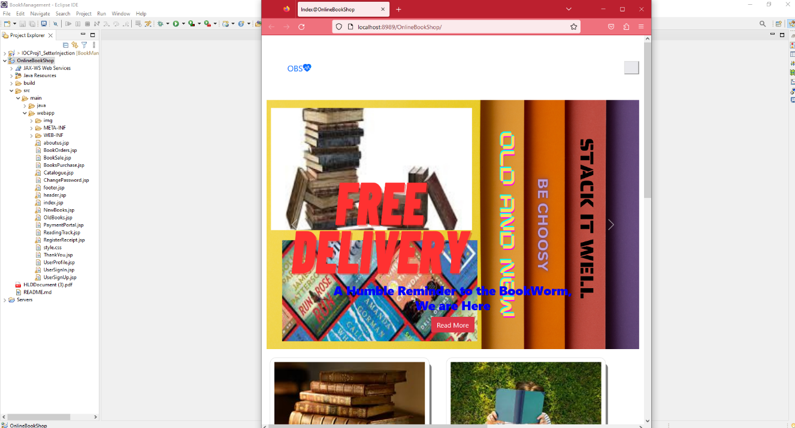

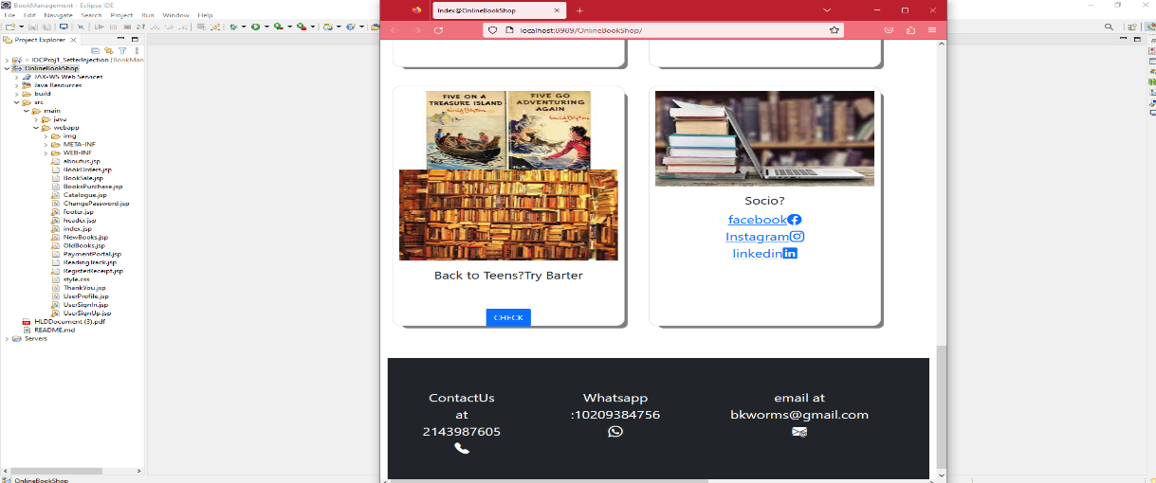

**aboutus.jsp**

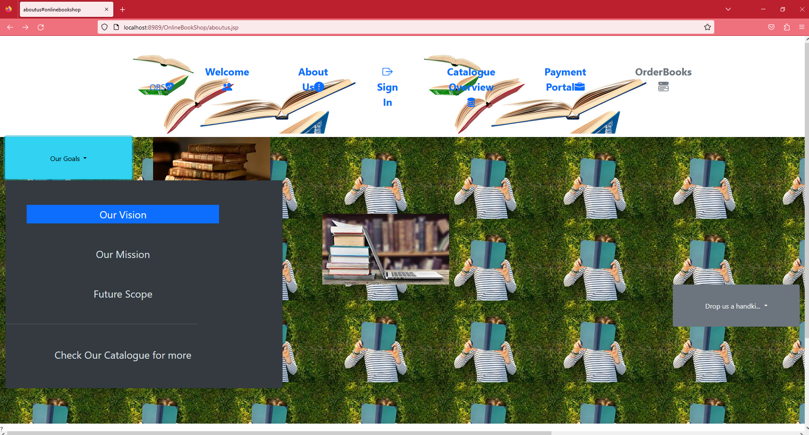

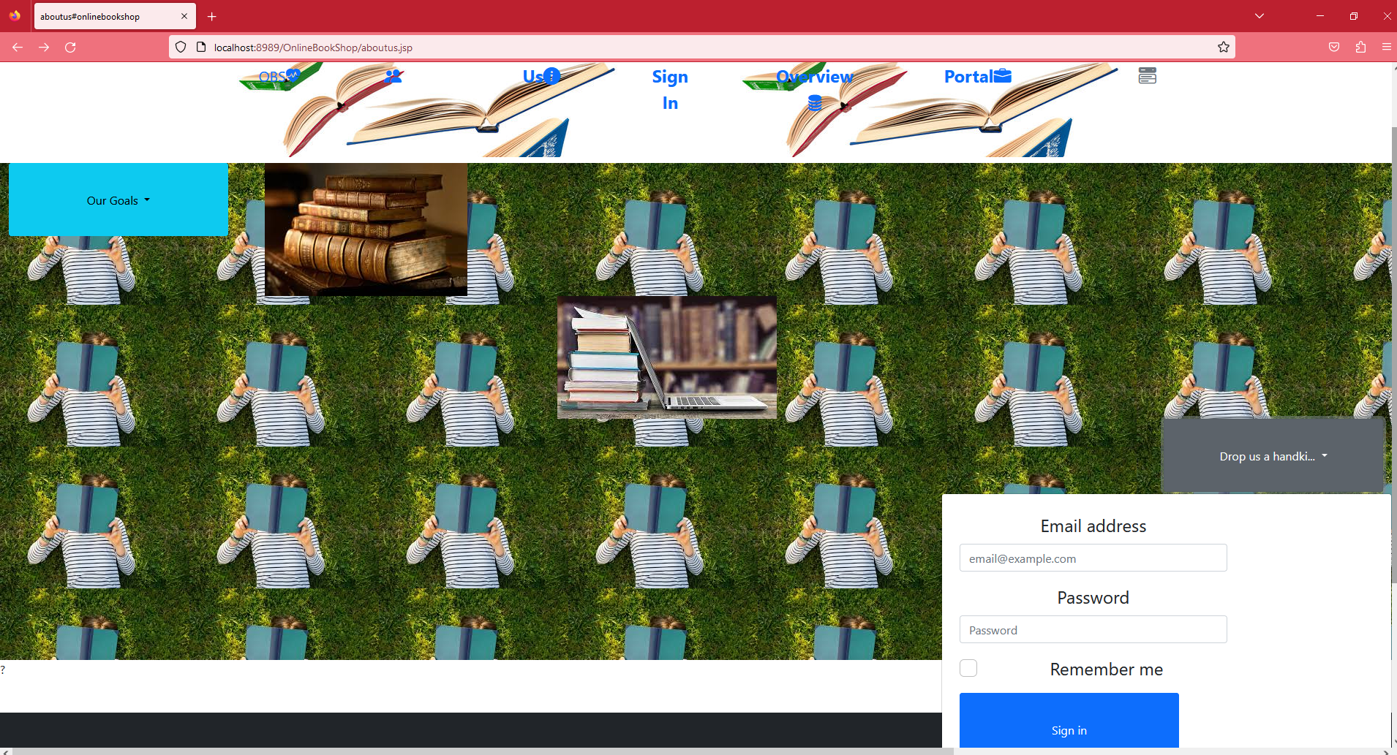

**A Catalogue overview page is accessible to all new visitors. It generates interest in them to register in the web-application.**

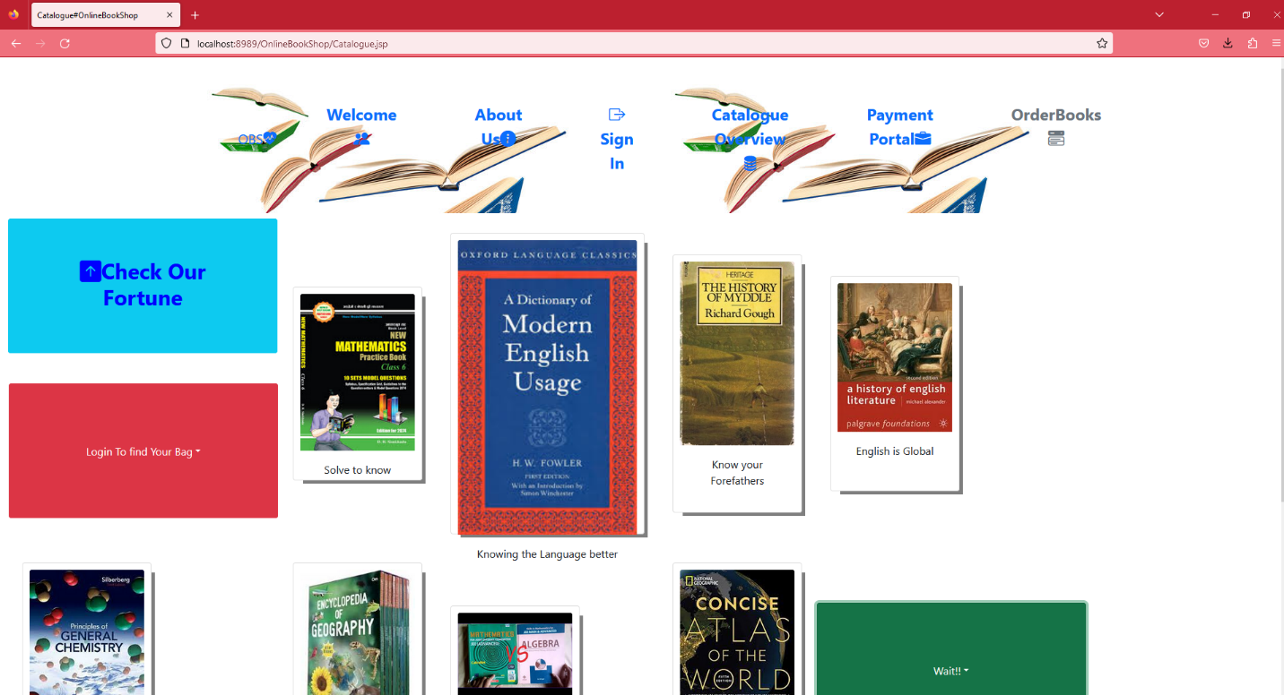

**It gives a offcanvas from top view:**

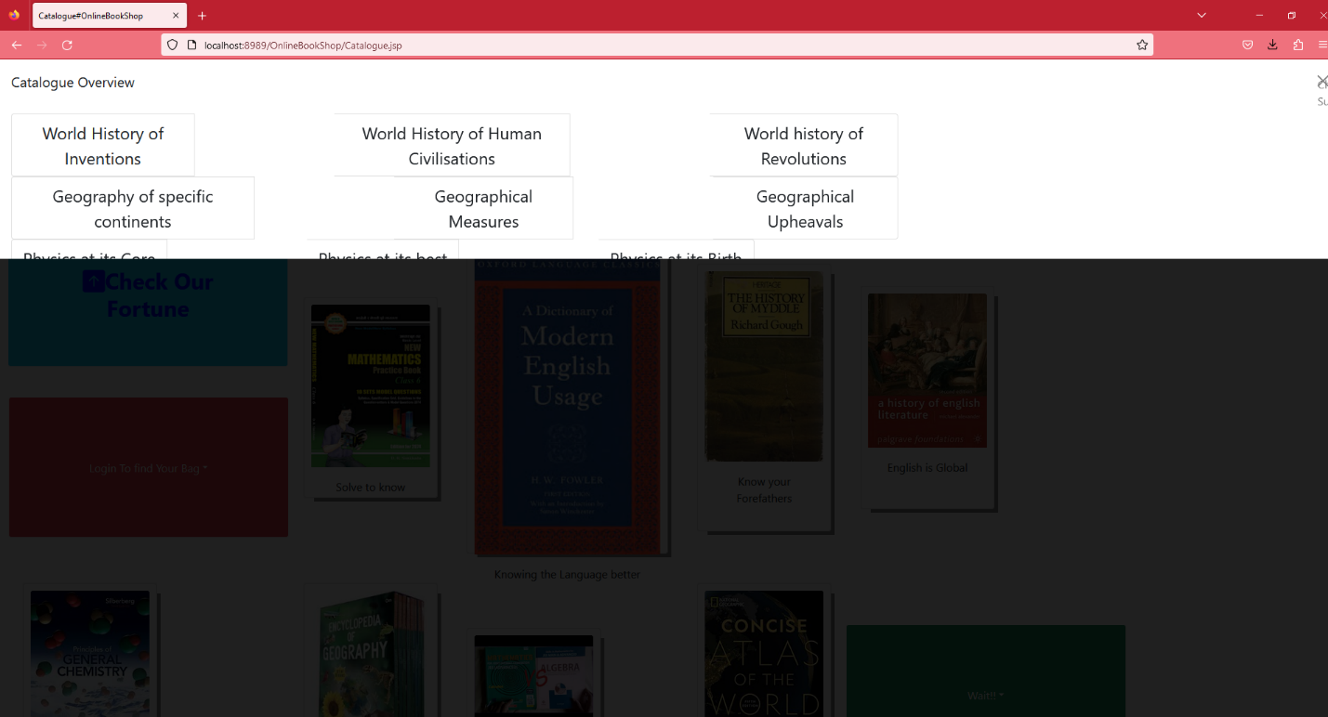

**UserSignUp.jsp page**

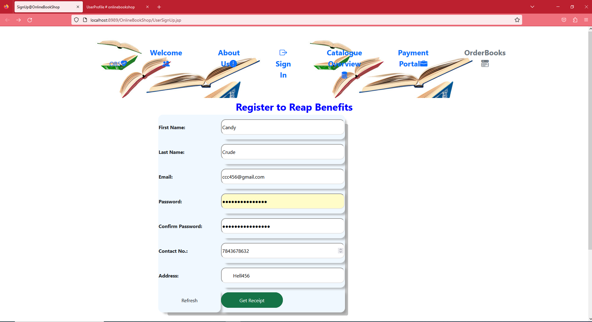

**This page redirects to a page to generate receipt by the RegistrationServlet.java[in package in.onlinebookshop.controller]:**

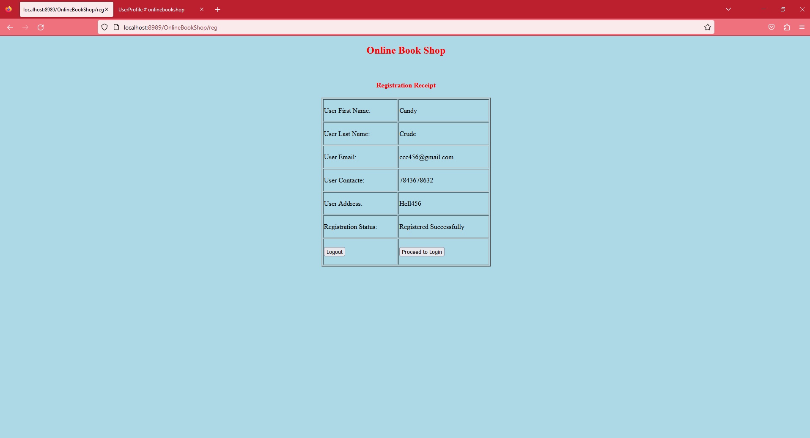

**UserSignIn.jsp:**

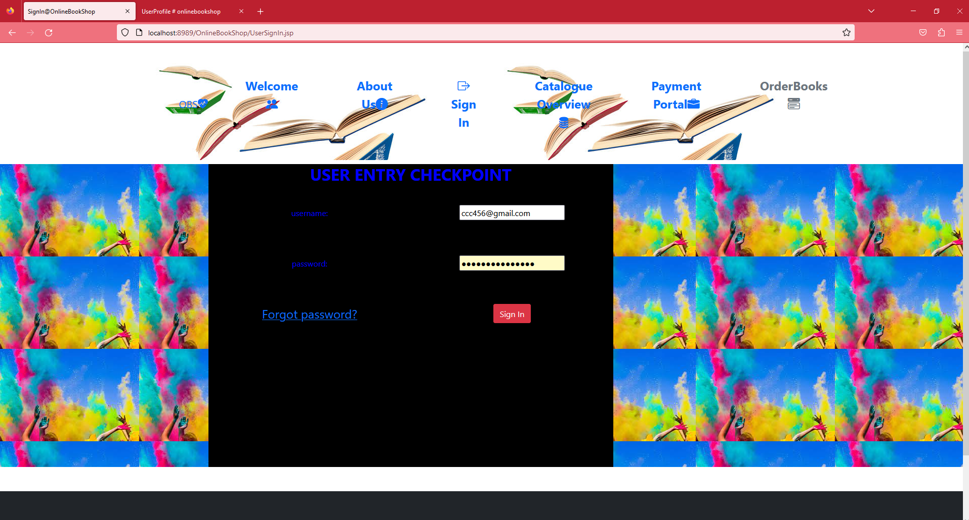

**This redirects to the UserProfile.jsp page:**

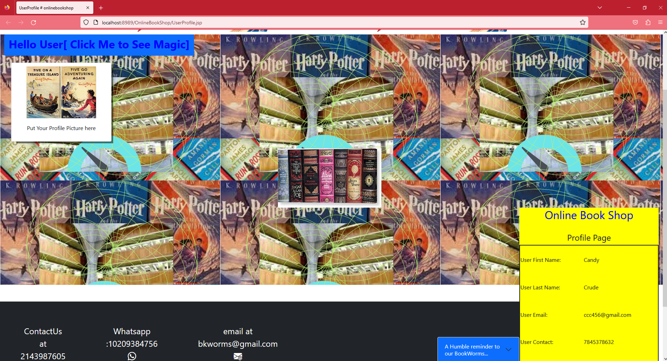

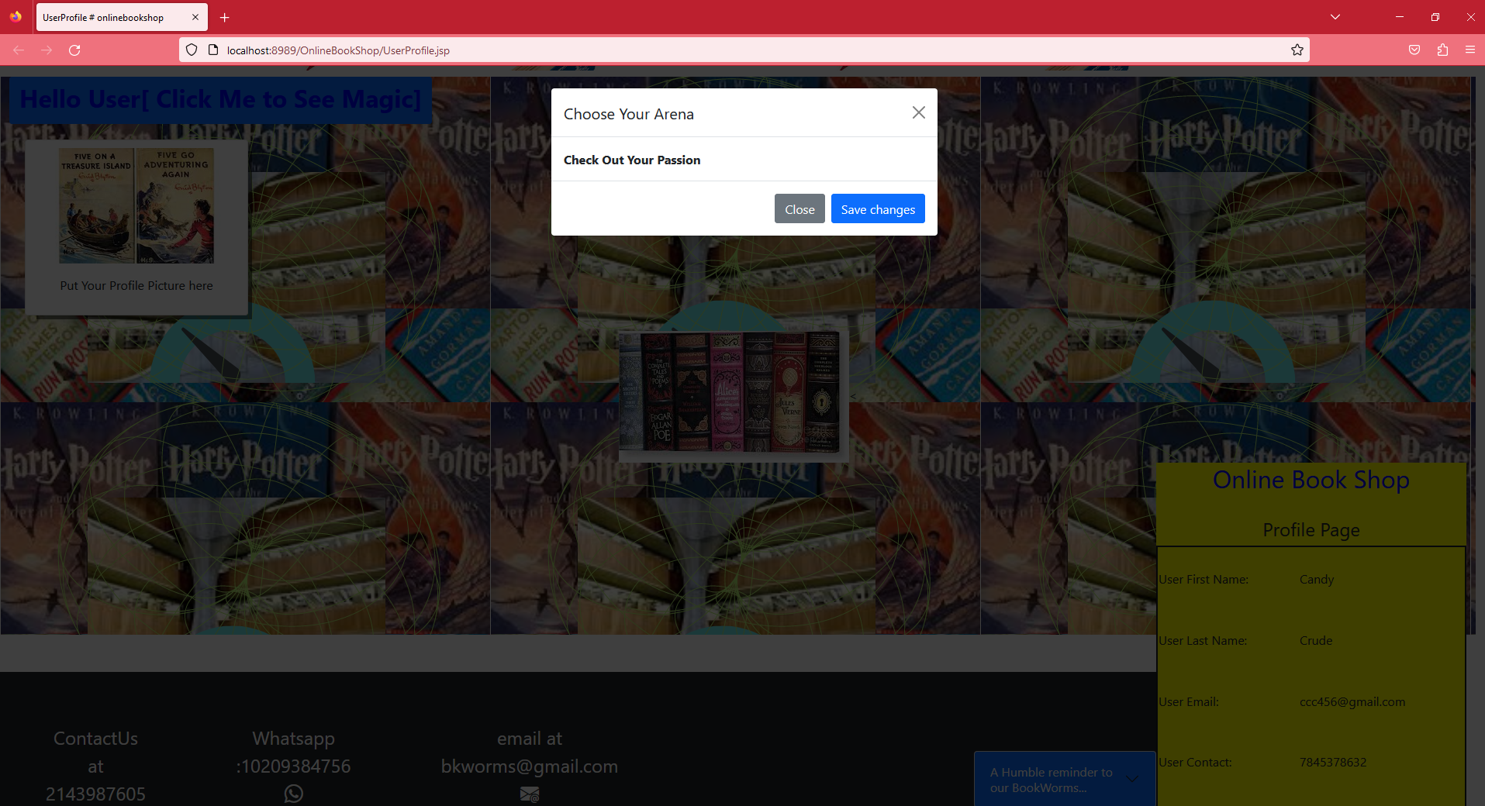

**readingTrack.jsp**

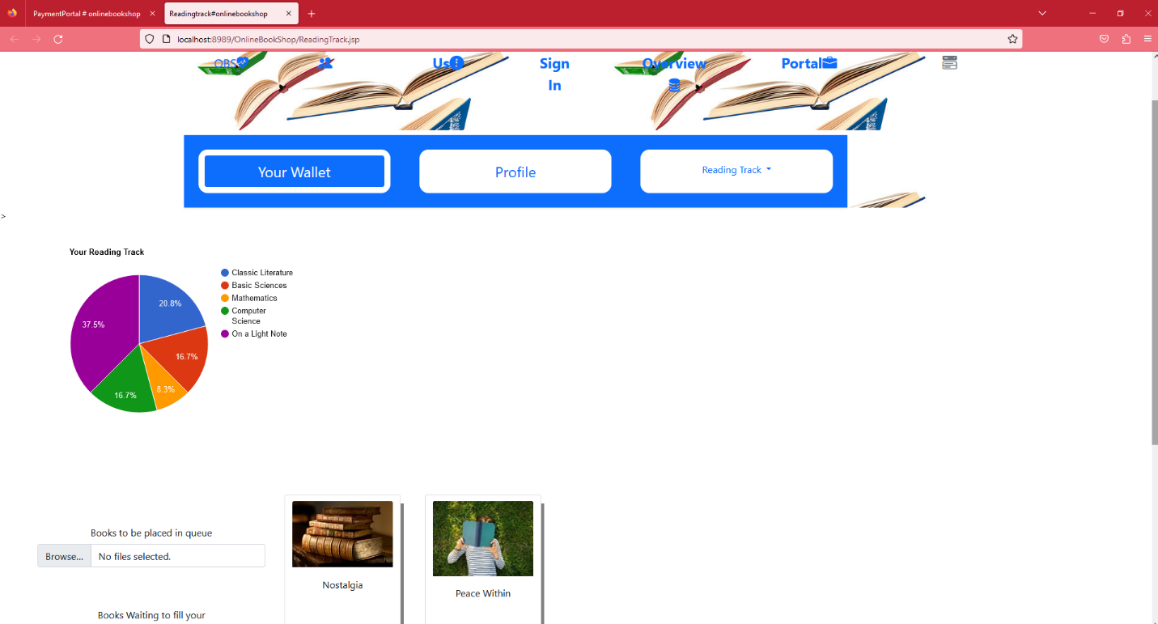

**NewBooks.jsp**

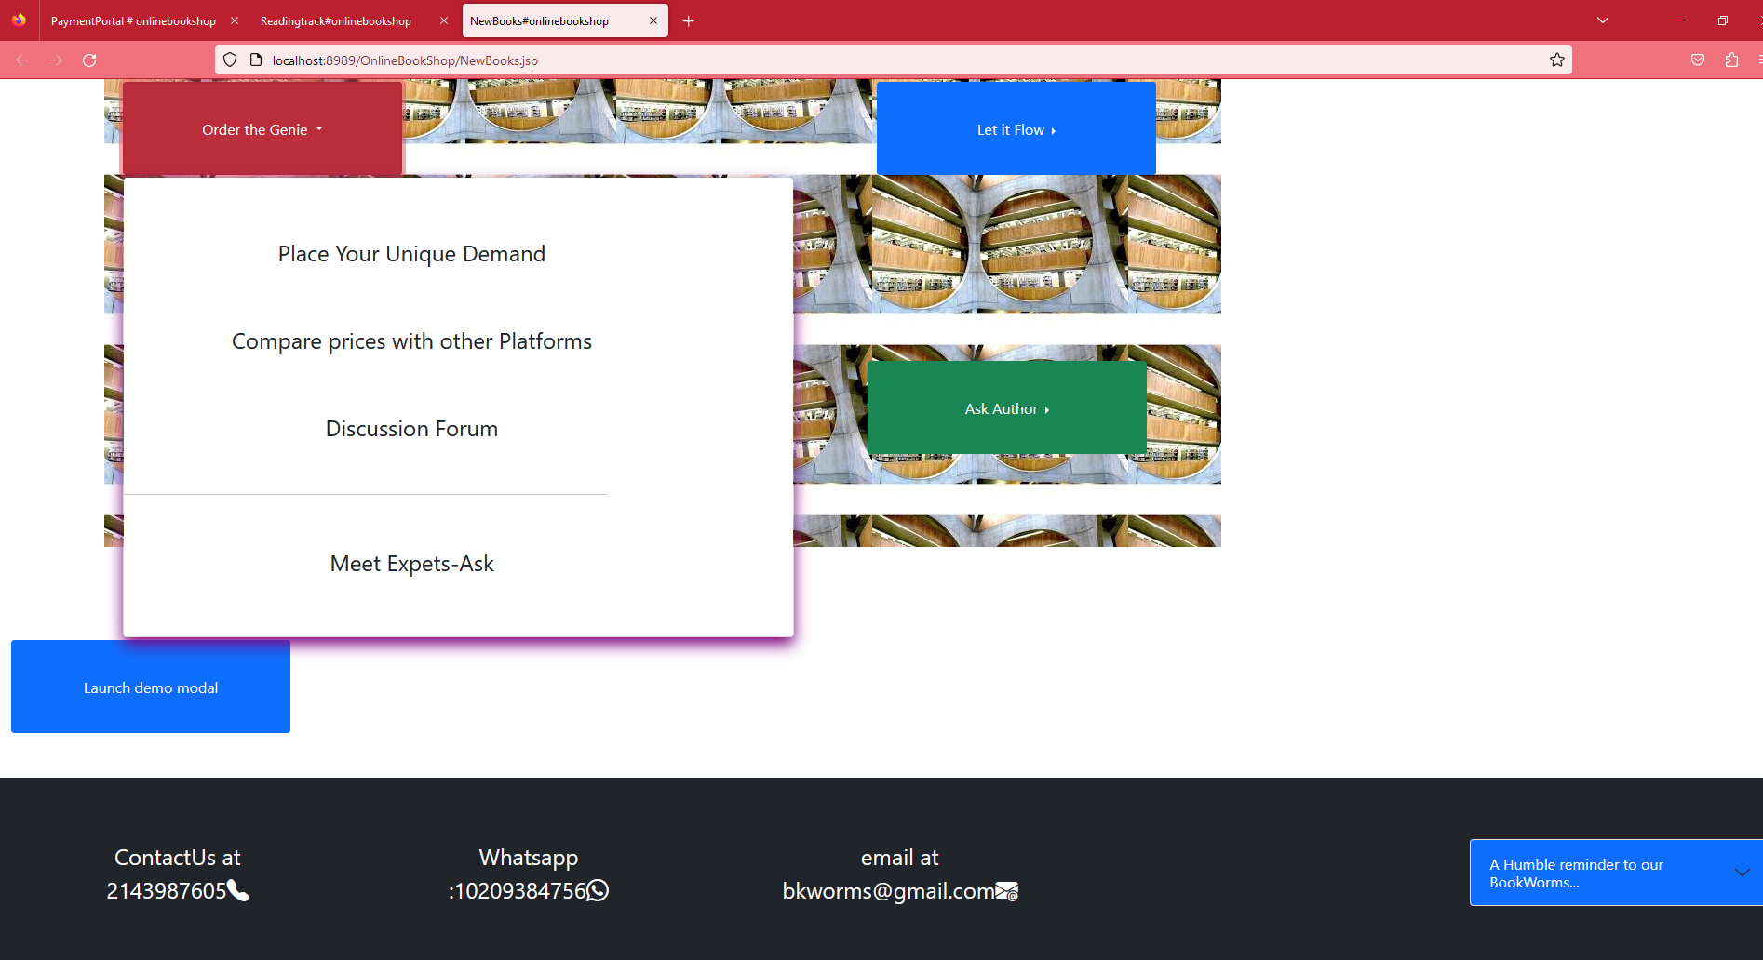

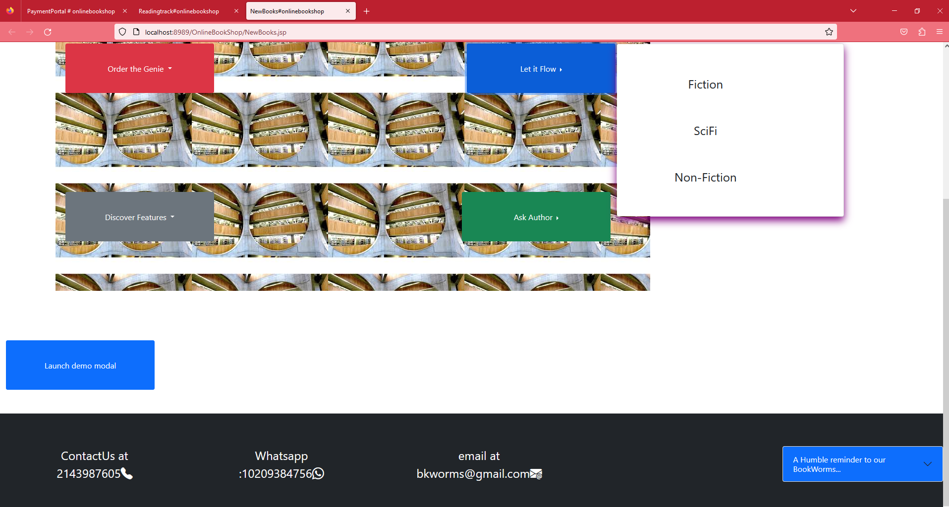

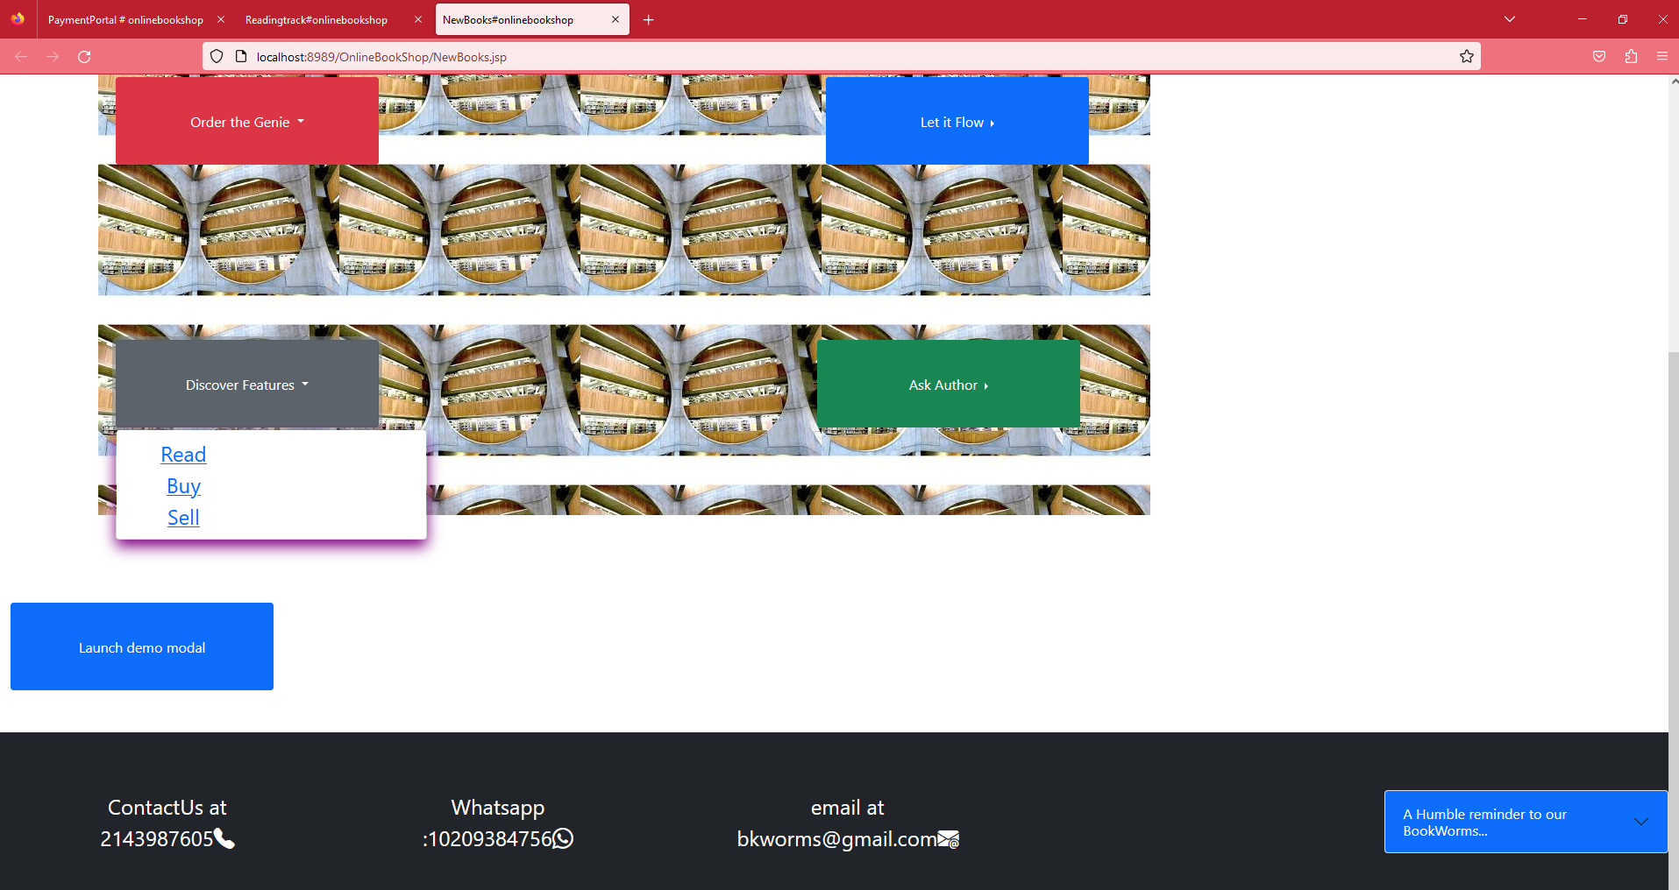

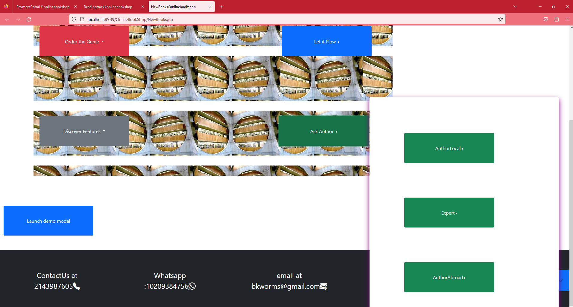

**OldBooks.jsp**

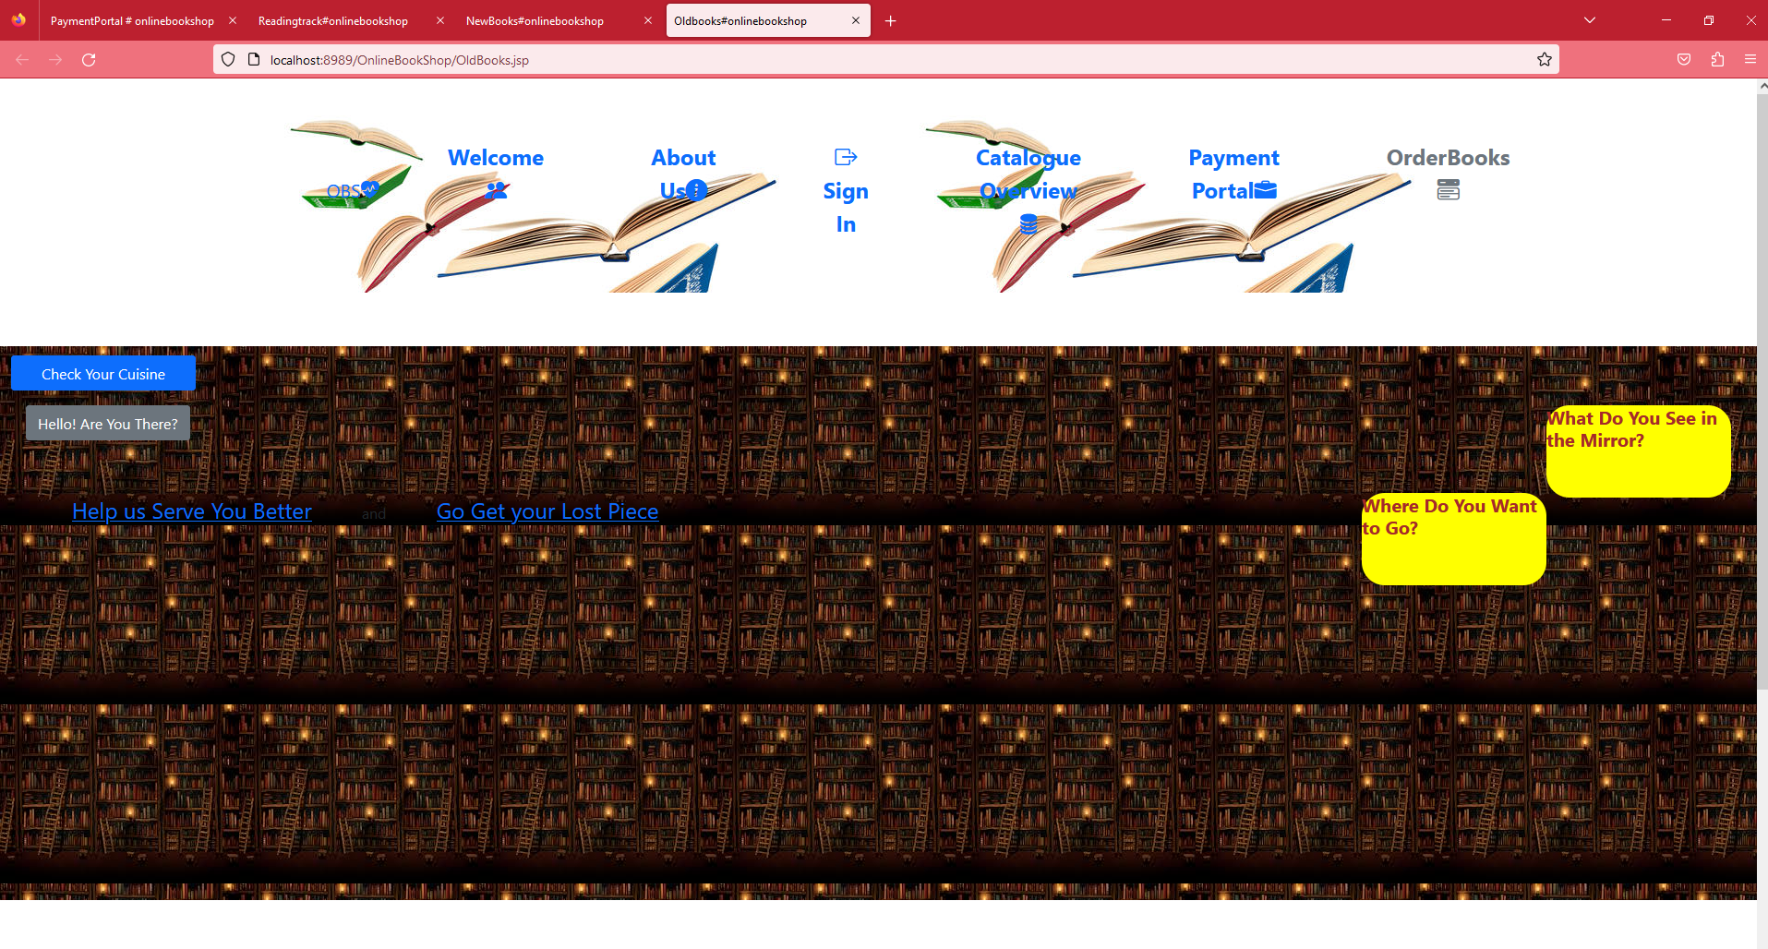

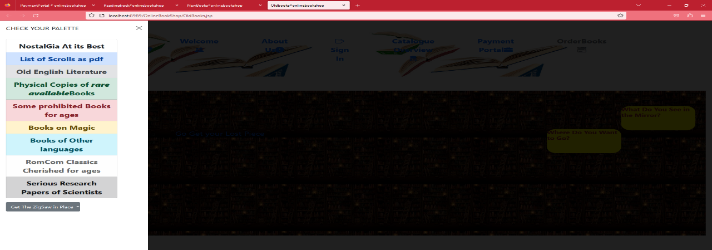

**OrderBooks.jsp**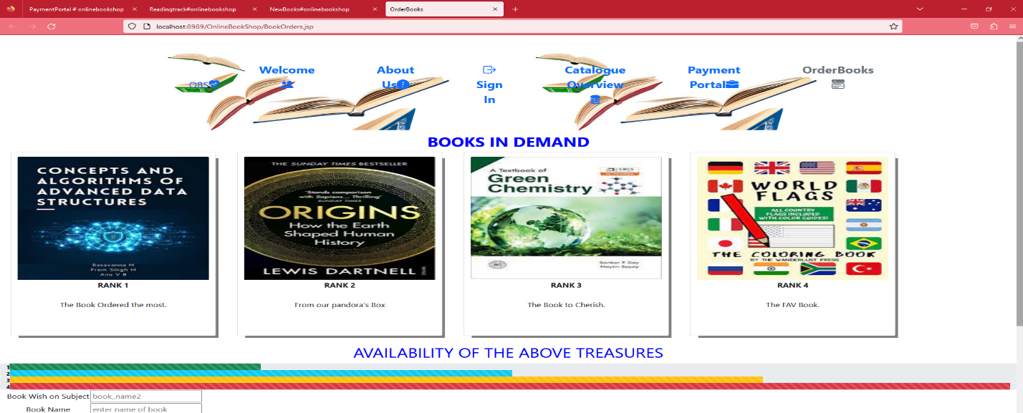

**paymentPortal.jsp**

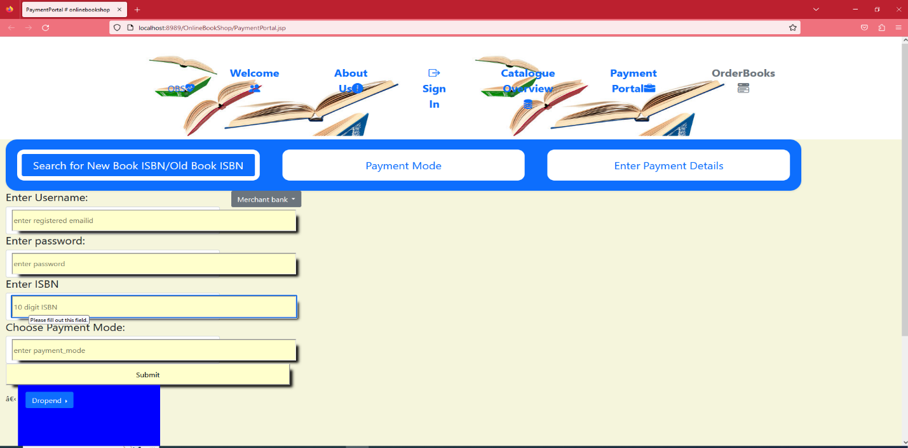

**AddNewBooks.jsp:** 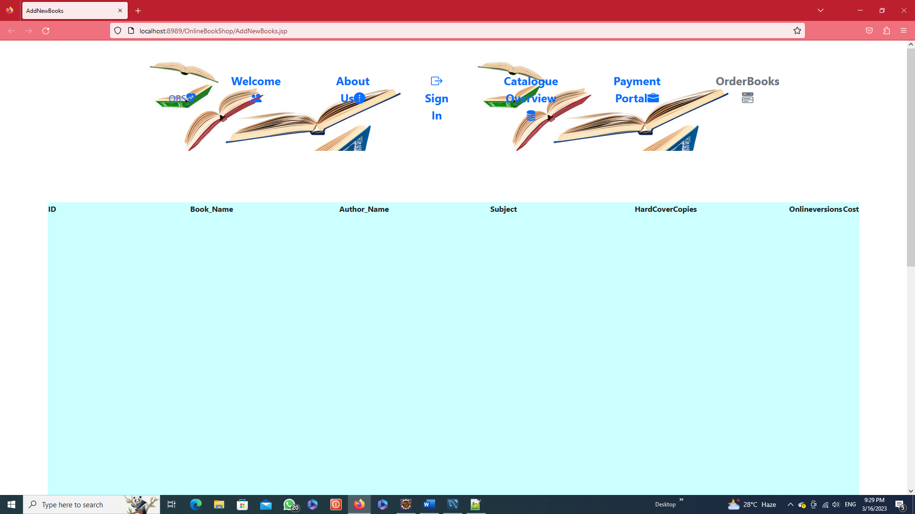

**BookSale.jsp**

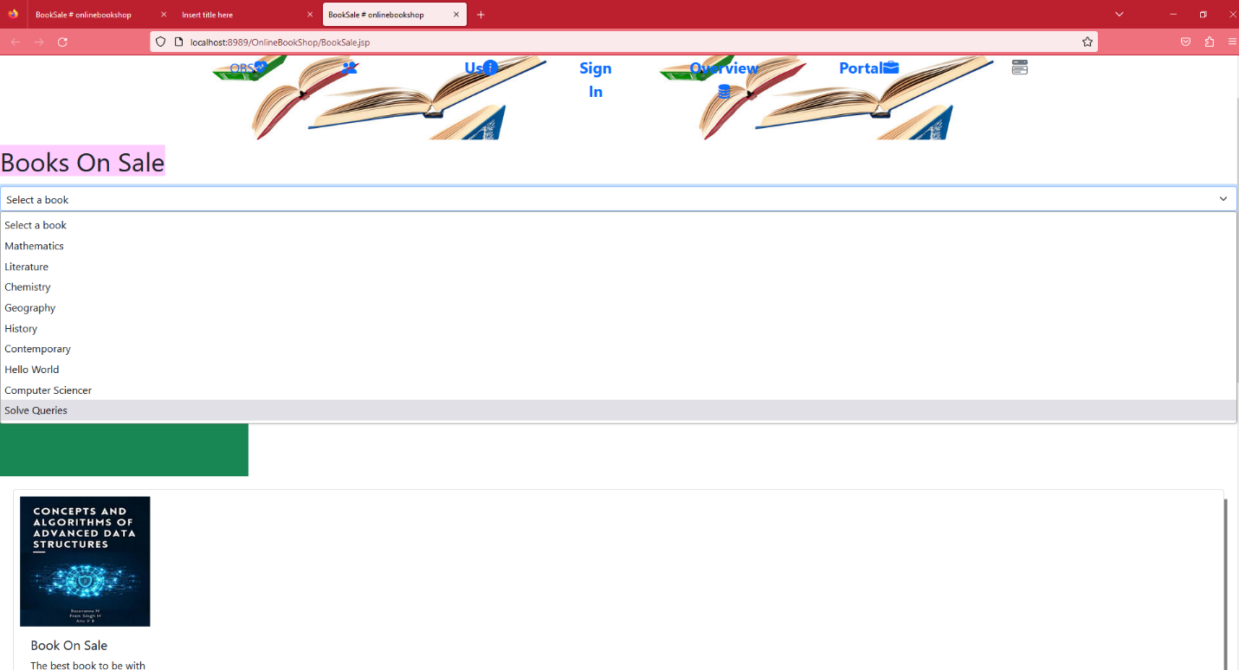

**BookPurchase.jsp**

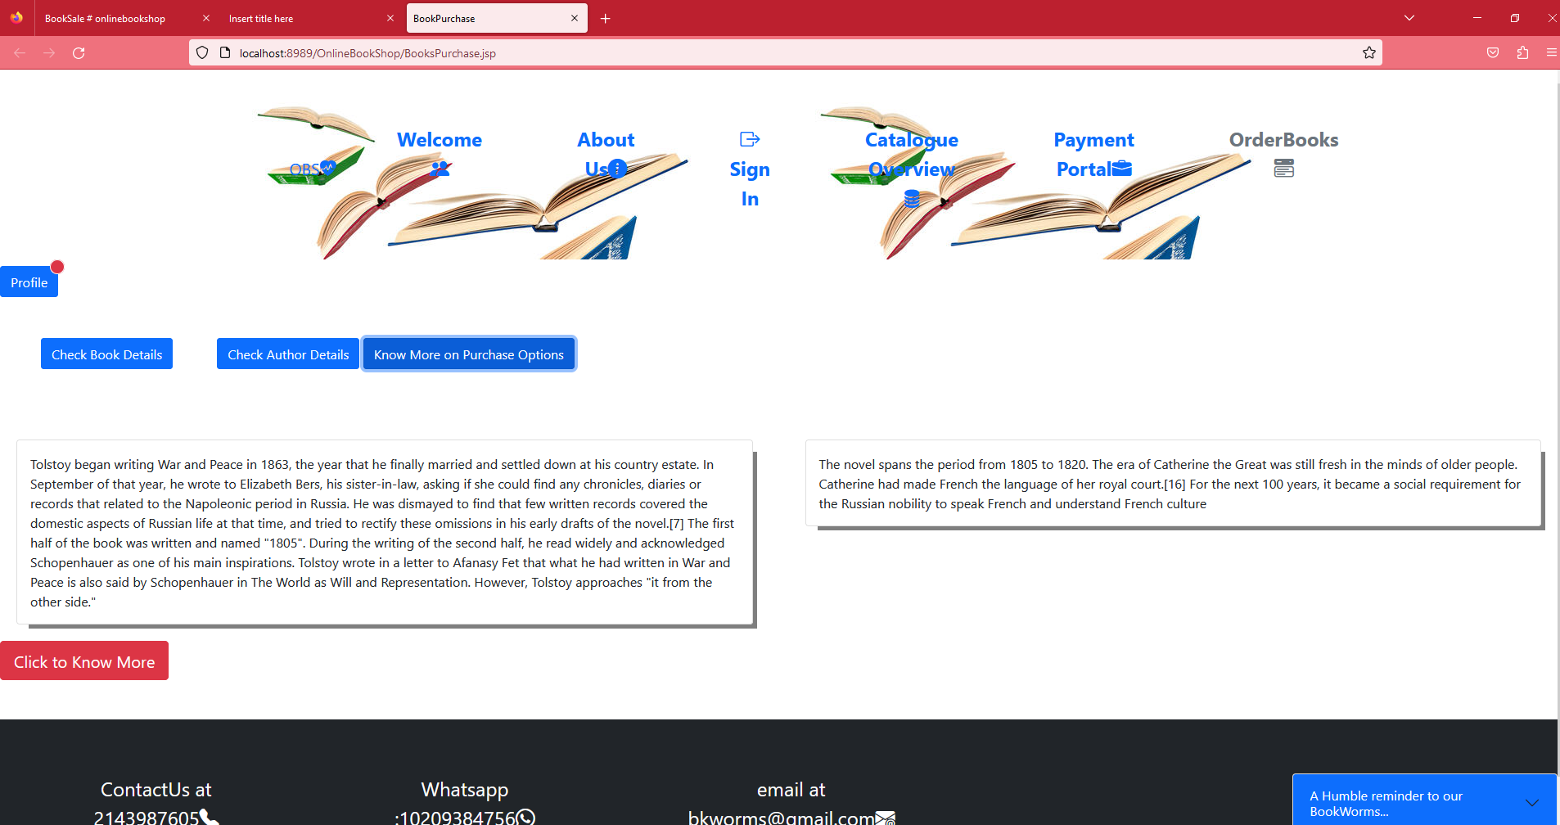

**ThankYou.jsp**

**[this invalidates the session]**

